

From Migrating Cell to Shape Space

# Terminologies for the Tutorial

To make the tutorial easy to read, a couple of terms are introduced:

* Movie folder: the folder containing your microscopy data
* Analysis folder: your folder containing the complete set of analysis files generated using the ShapeSpaceExplorer package described in this tutorial. For this tutorial it is important to save all outputs in this folder unless stated otherwise.
* Run a “specificMatlabFile.m”: this means, the path is added to your path, and a click on the “Run” button in the toolbar executes the program. Should these instructions feel unfamiliar, read the next Section “New to Matlab”
* Matlab: The program has been tested on Matlab 2017b on ubuntu 16.04 LTS.
* All figures produced in the tutorial are automatically saved in the folder Analysis→Figures unless specified otherwise.

# New to Matlab

If you have never used Matlab before, you should install the program and obtain a license first. Most universities offer free licenses for staff and students.

A comprehensive guide can be found at Mathworks

<http://uk.mathworks.com/help/install/installation-and-licensing-fundamentals.html>

The ShapeSpaceExplorer package has been tested with MatlabR2017b. If you are using any other version, not all functions might work properly. To download please perform the following steps:

* Login to [www.mathworks.com](http://www.mathworks.com/)
* Click My Account
* Click "Download Now" under Account Services, below the wording "MathWorks Account
* Click Download on the next page (under Licensed Products and Updates)
* On the following screen, there is a selection of the newest releases. To the right of the most recent version link, there is the link "Choose another release"
* After clicking select MatlabR2017b and proceed with download
* NOTE: This facility is not available for Student Version or trials since they are version specific.

To run the tutorial, you need the folder ShapeSpaceExplorer containing all files. Within the Matlab program go to the folder “ShapeSpaceExplorer” (see figure below).



Then, right click on ShapeSpaceExplorer folder, and select “Add to Path” → Selected Folders and Subfolders (see below)



This adds the ShapeSpaceExplorer to the Matlab paths, which means, the programs are easy to execute. The ShapeSpaceExplorer folder should appear as active (see figure below)



To run a program, open ShapeSpaceExplorer → 1-ImageSegmentationFull and select the File “Run_CellSegmentation.m” with a double click (see below). Then click on the “Run” button in the Toolbar. The first line in the command window should then contain the line   
>> Run_CellSegmentation

Once a program has finished properly, the Command Line shows a new line:

>>

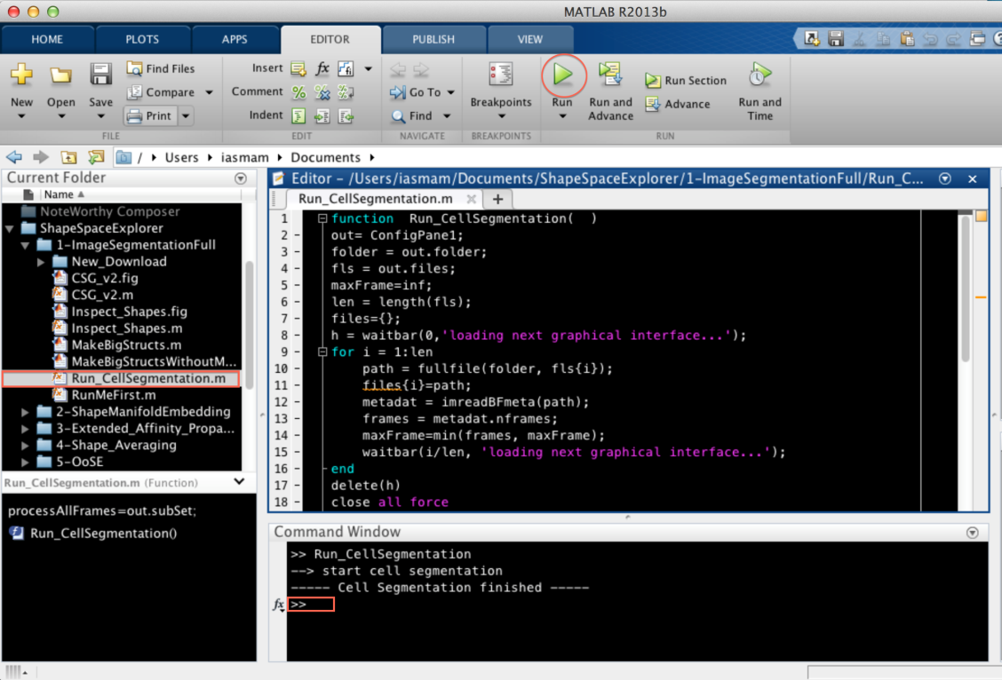

1st Step : Cell Segmentation

Cell Segmentation starts with the microscopy data in your Movie folder saved in Deltavision “.dv” file format.

To run cell segmentation, go to ShapeSpaceExplorer →1-ImageSegmentationFull, open the file “Run_CellSegmentation.m” and click on “Run” which should show the interface below:

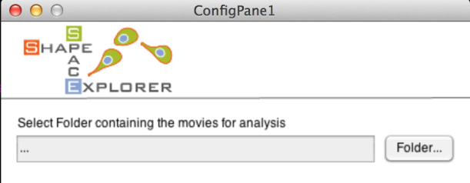

Select your Movie folder containing your microscopy data, which should show all files in a selectable list (see below).

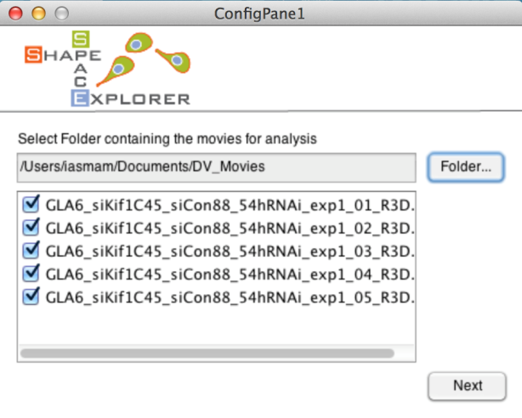

Select all movies that should be analysed. Note that at least one file must be selected to continue which should lead to the next interface (see next page). Note, the loading of the interface is slow, because it calculates the number of frames of your shortest movie from all movies files.

The interface offers two choices: first to analyse all movies from start to end (default choice) and second to select a substack of your frames, which might be helpful if your data went out of focus. Should you select a substack from frame A to frame B, this selection is automatically applied to all movies in your analysis.

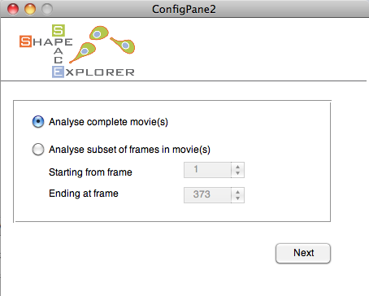

The final interface asks you for the Analysis folder to save the output of the cell segmentation (see below). Clicking on Start Pre-processing starts automatic cell segmentation. This is a time intensive task and can take several hours to a few days depending on your data size. Segmentation parameters ideally be optimised on a typical movie before running a large dataset (see Troubleshooting on page 8 for more information).

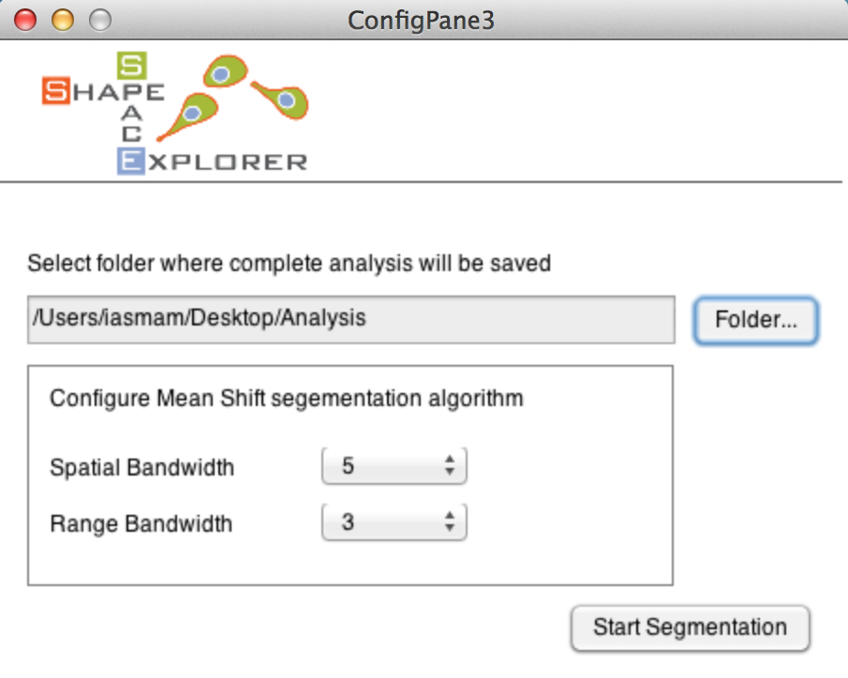

Two progress bars indicate the movie and frame that are currently processed. At the end, the commando line prints a note when the program finishes successfully (see example below).



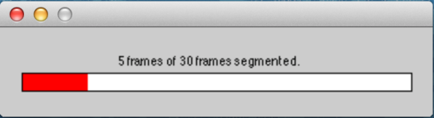



After cell segmentation, the Analysis folder should have the following new files:

* ImageStackXXX.mat for each selected movie
* ImageStackXXXCurveData.mat for each selected movie
* FileMapping.csv: contains the mapping between the new movie names and the original movie names from the Movie folder. Excel can import CSV files.

Note: for Matlab 2012b, the mapping is written to FileMapping.mat, as csv table writing is not supported.

**Step 1.1: Troubleshooting for Cell Segmentation**

The cell segmentation in ShapeSpaceExplorer uses an implementation of the Mean Shift Algorithm with the EDISON wrapper (**E**dge **D**etection and **I**mage **S**egmentati**ON**), The reference and details of the algorithm can be found in: D. Comanicu, P. Meer: "Mean shift: A robust approach toward feature space analysis." IEEE Trans. Pattern Anal. Machine Intell., 24, 603-619, May 2002.

NOTE: Should the segmentation produce strange outputs, then there are two parameters to adjust the algorithm: Spatial Bandwidth and Range Bandwidth.

These parameters are ideally optimised on a typical example image before attempting segmentation of a large dataset.

Generally speaking, the range bandwidth influences how much noise the cell segmentation picks up. Should there be too many smalls blobs recognized as cells, this parameter should be increased.

The spatial bandwidth, influences on how large the radius of a detected shape can be as smallest possible radius. Depending on your imaging conditions and average size of your cell, the interface permits to fine tune the cell segmentation step. Though, the proposed default values worked for a white range of cases.

An excellent detailed explanation on how the parameter influence cell segmentation can be found on Wikipedia: <http://en.wikipedia.org/wiki/Mean_shift>.

**Step 1.2: Manual correction of Cell Segmentation**

To inspect the cell segmentation results, run the file 1-ImageSegmentationFull→ Inspect_Shapes.m in the ShapeSpaceExplorer folder producing the interface below:

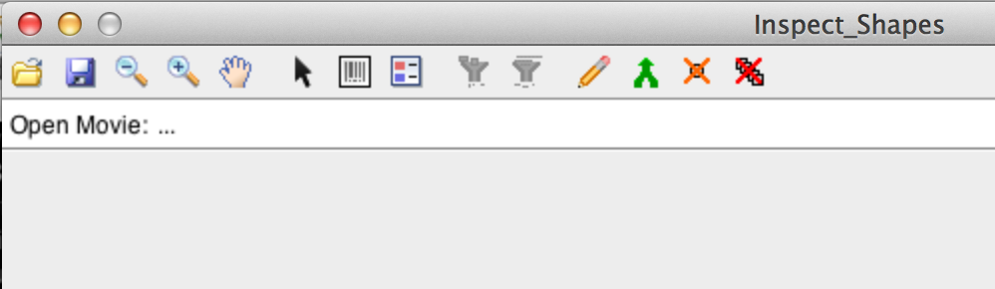

Click on the folder icon in the toolbar and select one of the files with the name format ImageStackXXX.mat, for example ImageStack001.mat. The program highlights the contours of the detected cells. The toolbar offers zoom in, zoom out and pan operations. The 8th icon from the left is the legend icons and permits you to see the id assigned to detected shapes.

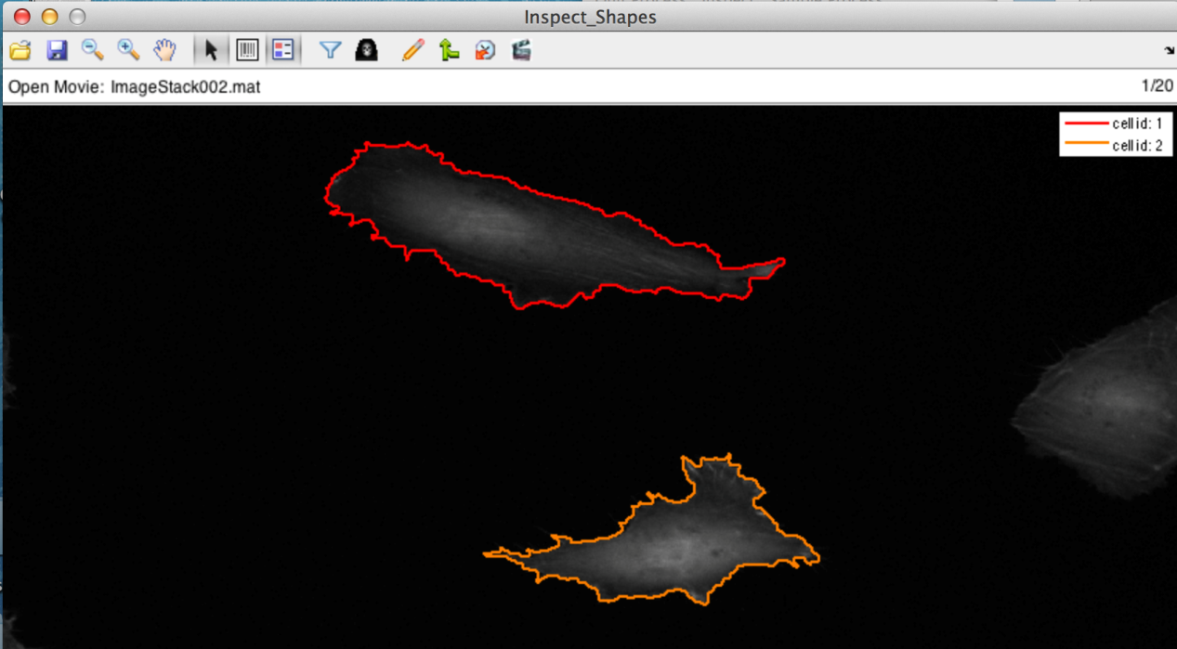

There are a variety of operations that permit to correct the automatic cell segmentation manually. Each of the operations is explained in the following sections.

**Step 1.3: Delete a single Shape**



Selecting the Cursor and clicking on a shape removes the shape from the detected cells, indicated by a grey outline. To remove a shape from a frame plus all future frame you need to hold down the key CTRL and click on the shape. To add the shape back to detected shapes, simply click with the Cursor selected inside the shape, which should re-colour the shape in a bright colour.

**Step 1.4: Filter out shapes with small area size**



The filter is applied to the complete stack. All active shapes smaller than your minimum size will become deselected.

Filter for sort live span



Merge



Manual Drawing



You have the full functionality of the Matlab ROI tool,

Full Description here: <http://uk.mathworks.com/help/images/ref/roipoly.html>

* Delete: Backspace
* Adding a new vertex: Key A
* Delete vertex: right click, and select delete
* Closing Polygon: Move to an existing point and click on it.

Continues tracks

For the analysis presented in this tutorial, continuous tracks are cell tracks that stretch from a start frame to an end frame, without any interruption. The cell with id one, appearing from frame one to five [1,2,3,4,5] would be an example.

However, if the track would have a missing frame, say at frame three, so that the sequence is [1, 2, 4, 5], then when the program saves your modification, it will assign a new id to the second part of the track.

When you save 3 new files should be produced:

* CellAray001.mat
* CellFrameData001.mat
* ManCorrtdCurves001.mat

# Step 1.5: After manual correction

The tutorial expects you to open each stack in InspectShape.m program and save it from there. For each stack ImageStackXXX.mat, the program creates two files, namely CellArayXXX.mat, and CellFrameDataXXX.mat.  
The analysis integrates only stacks that have those two files generated. To proceed run   
1-ImageSegmentationFull→MakeBigStructs.m

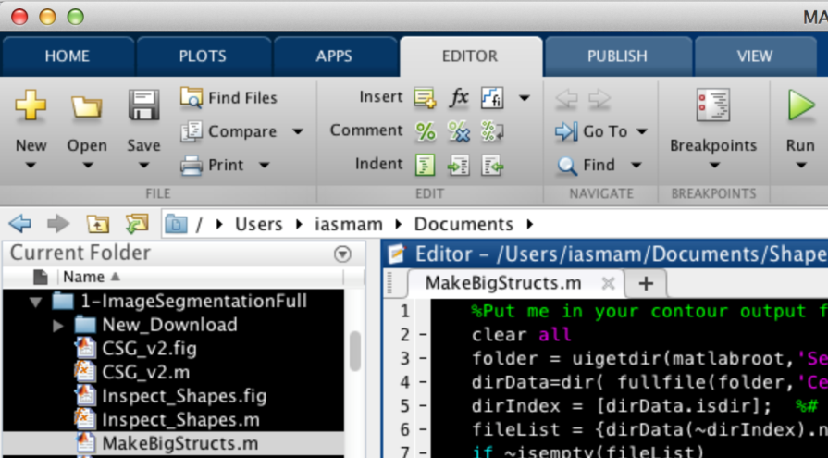

After selecting the Analysis folder, the program generates two files:

* Bigcellarrayandindex.mat
* BigCellDataStruct.mat

Note: you can construct the “Bigcellarrayandindex.m” and “BigCellDataStruct.mat” without manual correction; to do so, run   
1-ImageSegmentationFull→MakeBigStructsWithoutManual.m

Note: running the program MakeBigStructsWithoutManual.m will not include any existing manual corrections!

# Step 1.6: Manual segmentation

Manually segmented shapes (for example by drawing outlines using the freehand tool in ImageJ and exporting the xy coordinates into individual textfiles) can be imported into the Cell Shape Explorer.

Please note that files will be expected to be a tab-separated file with 3 columns. Following the header line these should contain only numbers. Point ID in the first column, x coordinates in the second column and y coordinates in the third column. These should be arranged in a folder structure as this:

Stack_001

Cell_001

Results_1.txt

Results_2.txt

Results_3.txt

Cell_002

Results_1.txt

Results_2.txt

Results_3.txt

Cell_003

Results_1.txt

Results_2.txt

Results_3.txt

Stack_002

Cell_001

Results_1.txt

Results_2.txt

Results_3.txt

Cell_002

Results_1.txt

Results_2.txt

Results_3.txt

Cell_003

Results_1.txt

Results_2.txt

Results_3.txt

Use the following Macro in ImageJ

//Macro allows manual extraction of cell shape and saves these as textfiles in the image folder.

macro "Get cell shape [1]" {

run("Clear Results");

getSelectionCoordinates(x, y);

for (i=0; i<x.length-1; i++){

setResult("y", i, y[i]);

setResult("x", i, x[i]);}

updateResults();

dir=getDirectory("image");

roiManager("Add");

nROI = roiManager("count");

selectWindow("Results");

name = dir + "Results_" + nROI + ".txt";

saveAs("Results", name);

setForegroundColor(255, 0, 0);

run("Draw", "slice");

}

Now, run 1-ImageSegmentationFull→ ImportManual_Segs_plus_Struct.m, which asks for the data folder as input. If run successful it will generate these two files:

* Bigcellarrayandindex.mat
* BigCellDataStruct.mat

Step 2nd : Shape Manifold Embedding

Now, run 2-ShapeManifoldEmbedding→ RunShapeManifoldEmbedding.m, which asks for the Analysis folder as input.

Once correctly completed, the following dialog box appears and should have created the file CellShapeData.mat in the Analysis folder

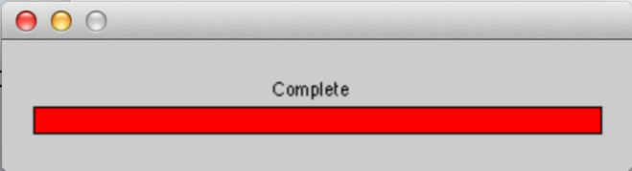

Note: this process is relatively slow: for a set of 4000 shapes, it takes only 8 minutes, while for 37818 shapes, the calculations require about 31 hours, approximately 1.5 to 2 days.

**Step 3rd: Display Shape Features**

To validate embedding, calculate and display shape features for all shapes.

To pre-process data for shape features run

3-ShapeFeatures →Run_ShapeFeature_Processing

select the Analysis folder. A progress bar should appear, indicating how long the program takes to complete. Took about 1.5 hours for 37818 shapes dataset.



After successful completion, the program should have created the file

* Morphframe.mat

Step 3**.1: Generate Shape Features**

To generate various shape feature plot, run

3-ShapeFeatures → generateShapeFeature

and select the type of graphs the program should create (the example below selected Area and Circularity):

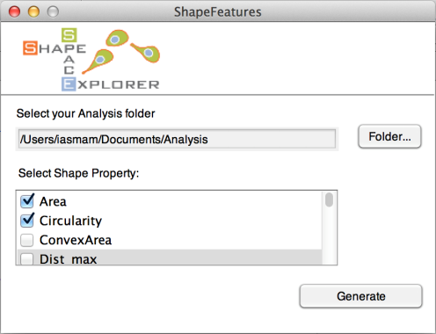

After successful generation, the programs plots all figures in the folder Analysis/Figures/3_ShapeFeature_<property>.eps

For Circularity, the file name is 3_ShapeFeature_ Circularity.eps (see below)

As a validation step, run 3-ShapeFeatures →Run_PlotBAMvsSCORES and select the analysis folder, then program will produce the following figures:

New Microsoft Office PowerPoint Presentation.tif

First and second rows (from left to right) show a comparison between ‘Score’ and ‘Solidity and DistRatio’ distributions, respectively, while third row shows regression lines on top of the shape distributions.

Note: please make sure that the BAM distance matrix (named ‘Dist_mat.mat’) is stored in the same analysis folder otherwise you can copy-past it to the same folder.

## Step 3.2: Interactive Shape Explorer

The interactive shape explorer permits to inspect the track of a single cell in shape space over time.

Run 3-ShapeFeatures→CellTrackViewer (see below)

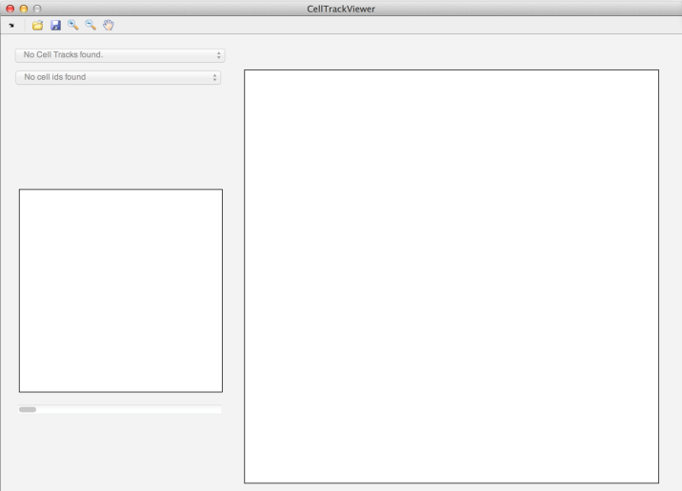

Then, click on the folder and open the Analysis folder. The first drop down menu permits to select the Image Stack of the sample, while the second drop down menu shows all non-empty cell-ids of this image stack.

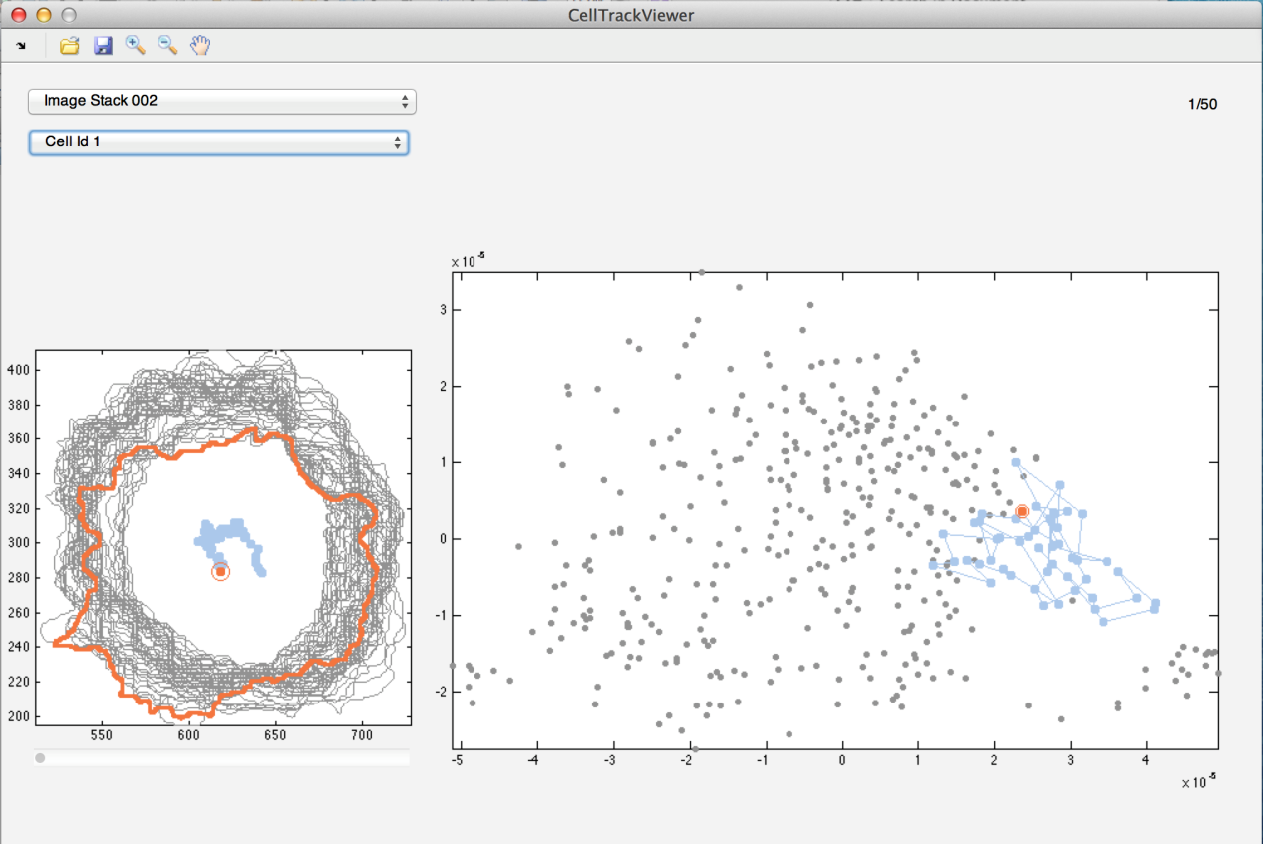

Note: when saving a track of a cell, the program saves a movie for the track in shape space and the shapes in the shape plot individually and combined in tiff format, as well as each frame in EPS format, which permits to edit them easily.

# Step 4th: Inspect Shape Space

This allows looking at individual and groups of shapes in the embedded shape space.

Run 4-Shape_Averaging →InteractiveShapeSlicer.m, click on the folder icon in the InteractiveShapeSlicer window and select the Analysis folder. This will show a plot of grey dots in shape space.

The data brush (sixth icon from left in tool bar) permits you to select a sub group of shapes (dots) in shape space. To produce the average shape space, click on the ‘Continue’ buttom on the down left corner of the interface to generate the average shape of selected group of shapes with its respective coloured shape space at the top right corner (as demonstrated in the figure below).

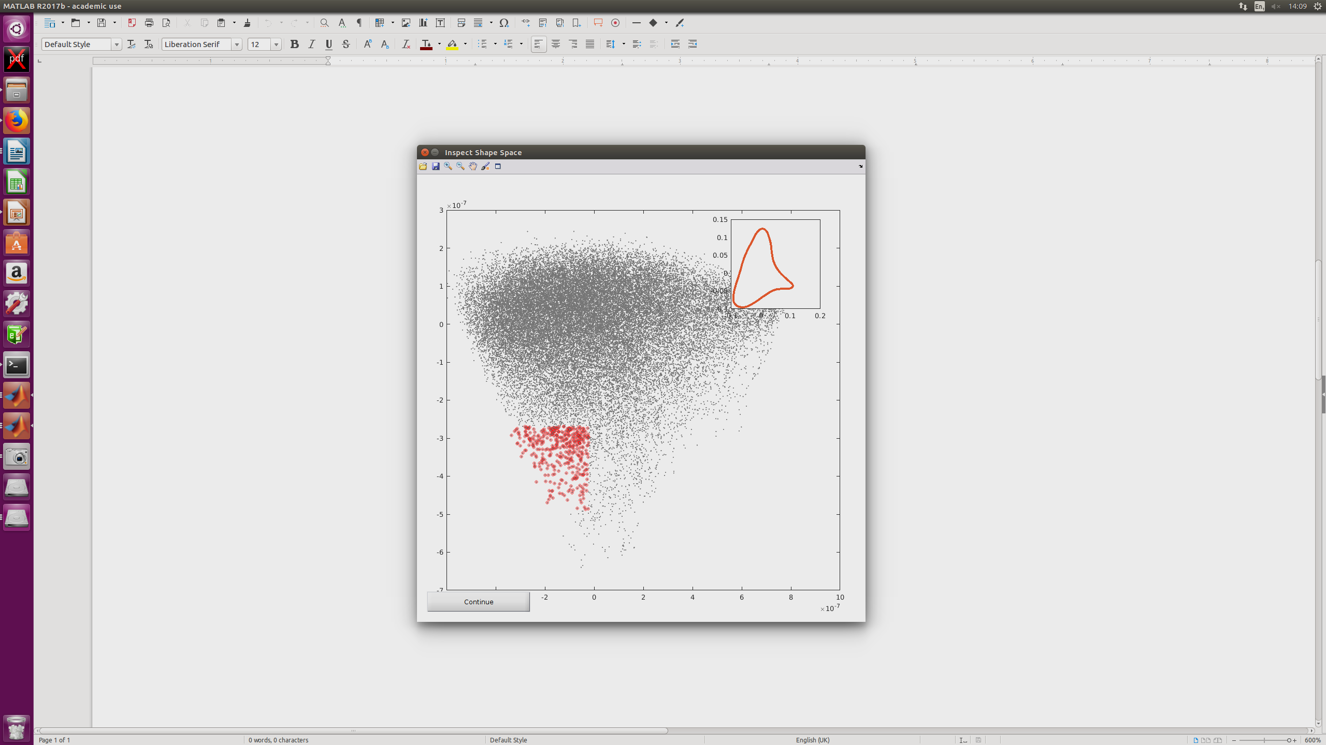

Click on the save icon in the tool bar to save both figures (average shape and respective shape space). You will be asked for a folder and name for the file.

# Step 5th: Extended Affinity Propagation (optional)

This step determines similarities between shapes.

In this step, similarities between shapes are determined. For pre-processing run

ShapeSpaceExplorer→5-Extended_Affinity_Propagation →Run_Affinity_Propagation.m

Note: this step needs first to load CellShapeData.mat; when this file is large, say about 20 GB, loading the file may take half an hour where the computer gives no feedback.

Once loaded, the program prints progress on the console.



After successful completion, the following nine files should have been generated in the Analysis folder:

* avail_list.mat
* APclusterOutput.mat
* double_sim_matrix.mat
* linkagemat.mat
* pref.mat
* resp_mat.mat
* single_sim_matrix.mat
* unconv.mat
* wish_list.mat

**Step 5.1: Inspecting automatic classification of shapes**

To inspect the automatic classification, run  
5-Extended_Affinity_Propagation → Inspect_ShapeAffinity.m , select the Analysis folder, and then the program produces two figures (see below)



The left figure shows the unordered exemplars with one example highlighted for each of 10 clusters, while the right figure shows ten example shapes from each cluster.

**Step 5.2: Dendrogram of Shapes**

Often, the program produces to many clusters and it is desirable to constraint the number of clusters. To make an informed choice, the cluster dendrogram should be consulted.

Run 5-Extended_Affinity_Propagation → Run_Dendogram_of_Shapes.m , select Analysis folder, and then the program produces the cluster dendrogram (see below). Use this to decide how many clusters are appropriate for the dataset.



**Step 5.3: Constrained Clustering**

Then run  
5-Extended_Affinity_Propagation → Run_constrained_Clustering.m,

select the Analysis folder and configure the number of clusters based on your choice made above (see figure below).

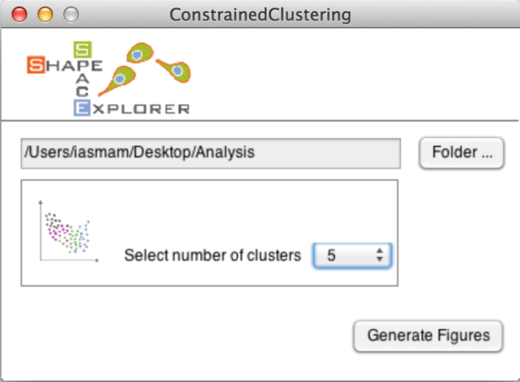

Note: The number you enter for constraint clusters must be smaller than the number of exemplars from the affinity propagation; otherwise the program terminates without results.

Left figure shows all shapes in shape space coloured in the cluster colours. Each dot in the figure corresponds to a cell shape. The x and y axes are the first two Diffusion Coordinates. The right figure the ordered list of exemplars coloured in the cluster colours.

# *Step 5th: Group Analysis*

A classical example for group analysis might be that your data is divided into three samples: control, treatment1 and treatment2. This group analysis permits to analyse cluster membership for each group and the speed and directionality of shape changes for each group.

Run 5-Extended_Affinity_Propagation → Run_GroupAnalysis.m

Please select the Analysis folder and the ideal number of clusters as determined in Step 3a.

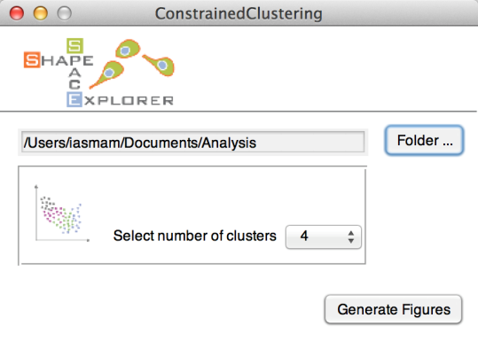

Define the Groups by entering a group name and the stack number. A mapping between stack number and original file is in ‘FileMapping.csv’, generated in the cell segmentation step.   
Note: Avoid special characters and white space for group names as they are used later directly in figure paths, and may cause issues on some operating systems.

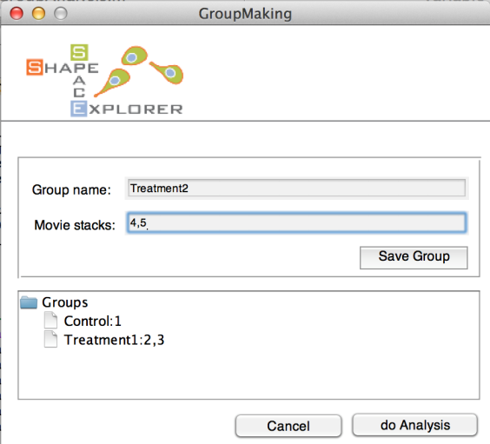

Note: stack numbers from one to five can be entered in several ways, such as

* 1-5
* 1,2,3,4,5

To delete a group, hold CTRL and click on the group, which produces a context menu with a delete option.

For each group analysis, the program creates a new folder with time stamp, for example “GroupAnalysis_2015-04-15_095836”. The folder contains the following results for each group:



Left images shows shape space in gray, with group elements in cluster colour, while right image shows group elemetns as full circles and non-group elements as empty circles in shape space.



Left figure shows the relative amount of shapes in the clusters, while right figure shows Eucledian ratio persistency of the group, a ratio between accumulated distance and shortest possible distance over different time lags.



Left figure shows relative count of all groups with respect to cluster 1 (red), while right figure shows bar plots with absolute counts. For all bar plots, the numbers are written in text format in the Group Analysis folder.

Finally, the averages speed in shape space is written in “AvgSpeedPerGroup.csv”. The unit of the speed is [unit in shape space/ time point difference]. If your movies took a frame every 5 minutes, than the respective unit would be

[1 unit in shape space/ 5 minutes].

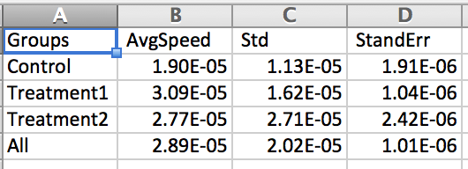

# *Step 5.1: Shape Slicer*

To run the shape slicer, go to folder 4-Shape_Averaging and run “Run_SpaceSlicer.m”, which opens a configuration window (see below).

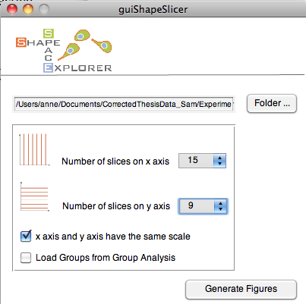

Select the Analysis folder and the number of slices the x and y axis should be divided into. The program produces the figure below.

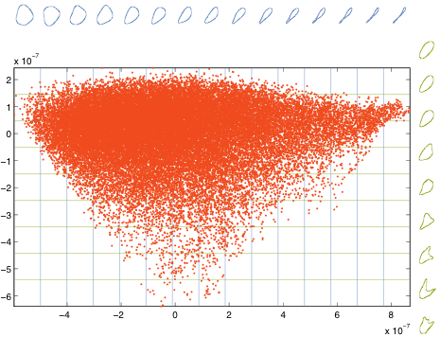

Each dot corresponds to a shape in shape space. Here, the x-axis is sliced into 15 sections. For each section, the program produces an average shape (see blue shapes). Similarly, the y-axis is sliced into 9 sections, and the respective average shape is plotted in green.

To make the results graphically more appealing, the program writes the single items, such as contents and average shapes of x- and y-axis into single figures, permitting to edit the elements in graphic programs able to deal with EPS file format.

# *Step 5.2: Space Slicer with Group Analysis*

# Macintosh HD:Users:iasmam:Desktop:Screen Shot 2015-06-04 at 20.14.14.png

To see the group distribution in space slicer, tick the last choice box (load group analysis). Then, the program ask for a group folder (see below)

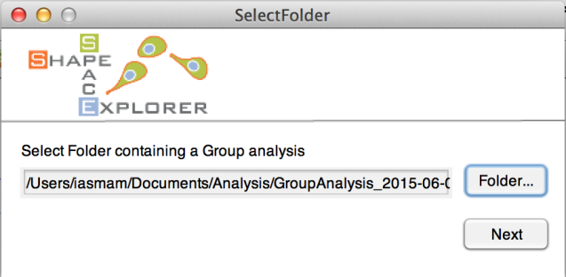

Below is the shape space sliced, with the coloring of the group analysis and the associated histograms for the defined groups.



# Step 6th: Out of sample extension

First step: create a folder called OOSE (possibly inside Analysis folder), then perform the following two preparatory steps:

* Run 1-ImageSegmentationFull → Run_CellSegmentation.m and select OOSE as your Analysis folder
* Either correct Data manually, using “Inspect Data” for all ImageStacksXXX.mat and run   
  1-ImageSegmentationFull → MakeBigStructs.m or continue without inspection running

1-ImageSegmentationFull → MakeBigStructsWithoutManual.m

Now, run 6_OoSE →run_OoSE_training and configure the next step (see below)

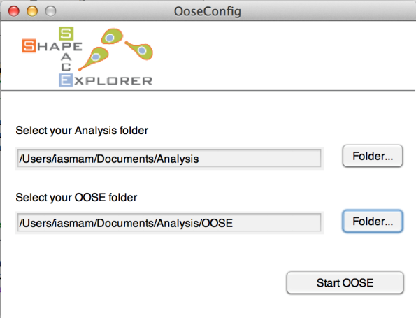

Once completed successfully, the OOSE folder contains the new file:

* LP_trained.mat; its structure has Nx5 matrix, where N is the number of frames analysed.

Now, run 6_OoSE →generate_OoSe_distMatrix_new (Choose analysis and OoSE folders as above and click “Start OOSE” in similar way to the previous step).

After correctly finishing, there will be one new file in the OOSE folder:

* Dist_mat.mat
* OoSE_embedding.mat

To compare the OOSE sample within the shape parameters and cluster parameters of say the control sample, run

6_OoSE → createBargraphs.m

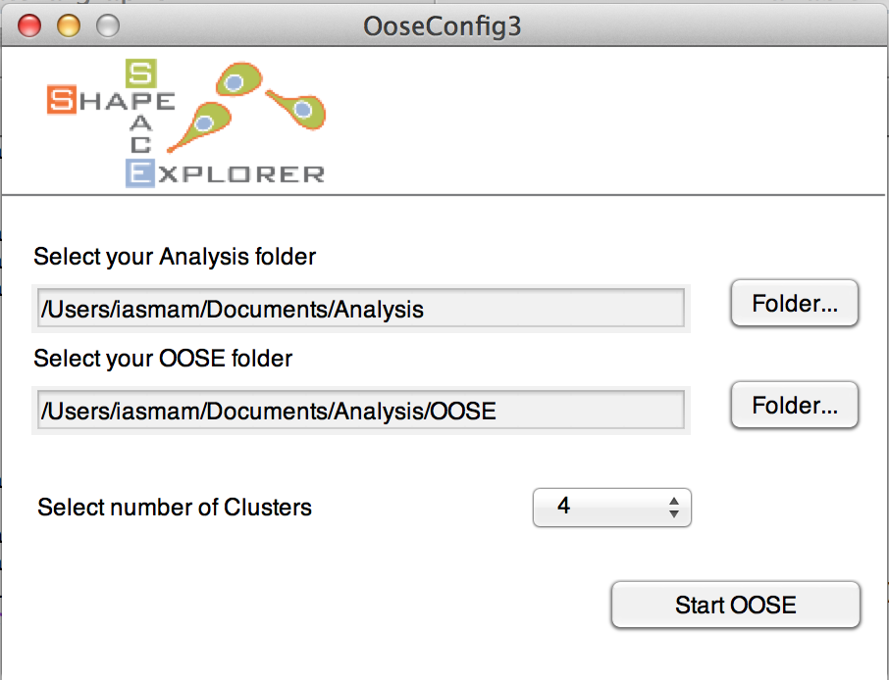

For clusters, select the best numbers from the reference (Analysis) sample. The new subset will be plotted in shape space using the two most distinctive features for x- and y-axis from the larger sample in Analysis. Also, for the clustering, the sample in Analysis is used as ‘reference’ clusters, and this permits to see how this sample extension compares to a larger sample or a control sample.





Left: shows bar graphs for clusters with absolute numbers, middle shows shape space with reference dots in grey and sample extension in colour, right figure plots extension shapes in full circles and reference shapes in empty circles.

Note: All Figures are plotted in OOSE/Figures, with numbers of bar graphs written in CVS files.

# Step 7th: Shape Space Dynamic

## Step 7.1: Group analysis including OoSE data and cluster to cluster speed

First, please make sure that the Neural Network Toolbox is already installed. If not install it by clicking on the Home tab, click Add-Ons (stacked cubes icon) -> Get Add-Ons. This launches the Add-On Explorer that lists all toolboxes from MATLAB -> search for Neural Network and install it.

Then, run 5-Extended_Affinity_Propagation → Run_GroupAnalysisNEW.m

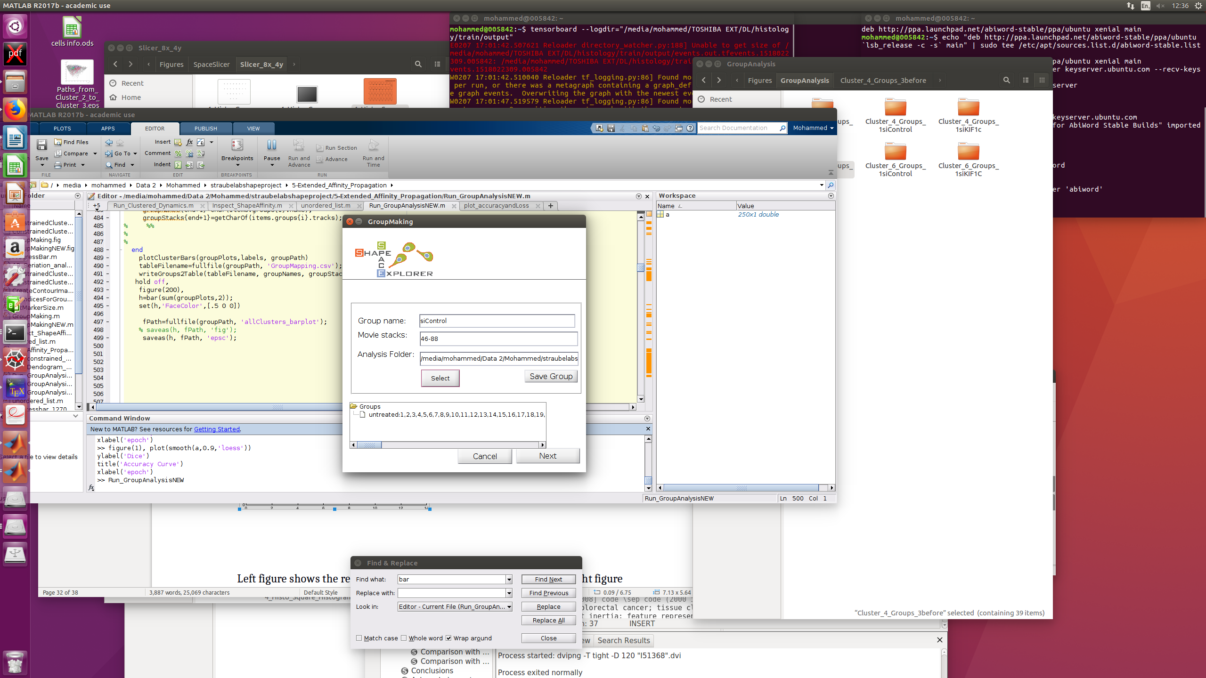

Define the Groups by entering a group name, the stack number, and the associated analysis folder. A mapping between stack number and original file is in ‘FileMapping.csv’, generated in the cell segmentation step.   
Note: Avoid special characters and white space for group names as they are used later directly in figure paths, and may cause issues on some operating systems.

Note: stack numbers from one to five can be entered in several ways, such as

* 1-5
* 1,2,3,4,5

To delete a group, hold CTRL and click on the group, which produces a context menu with a delete option.

Now, configure the number of regions by selecting the number of rows and columns of the shape space to be divided (see figure below).

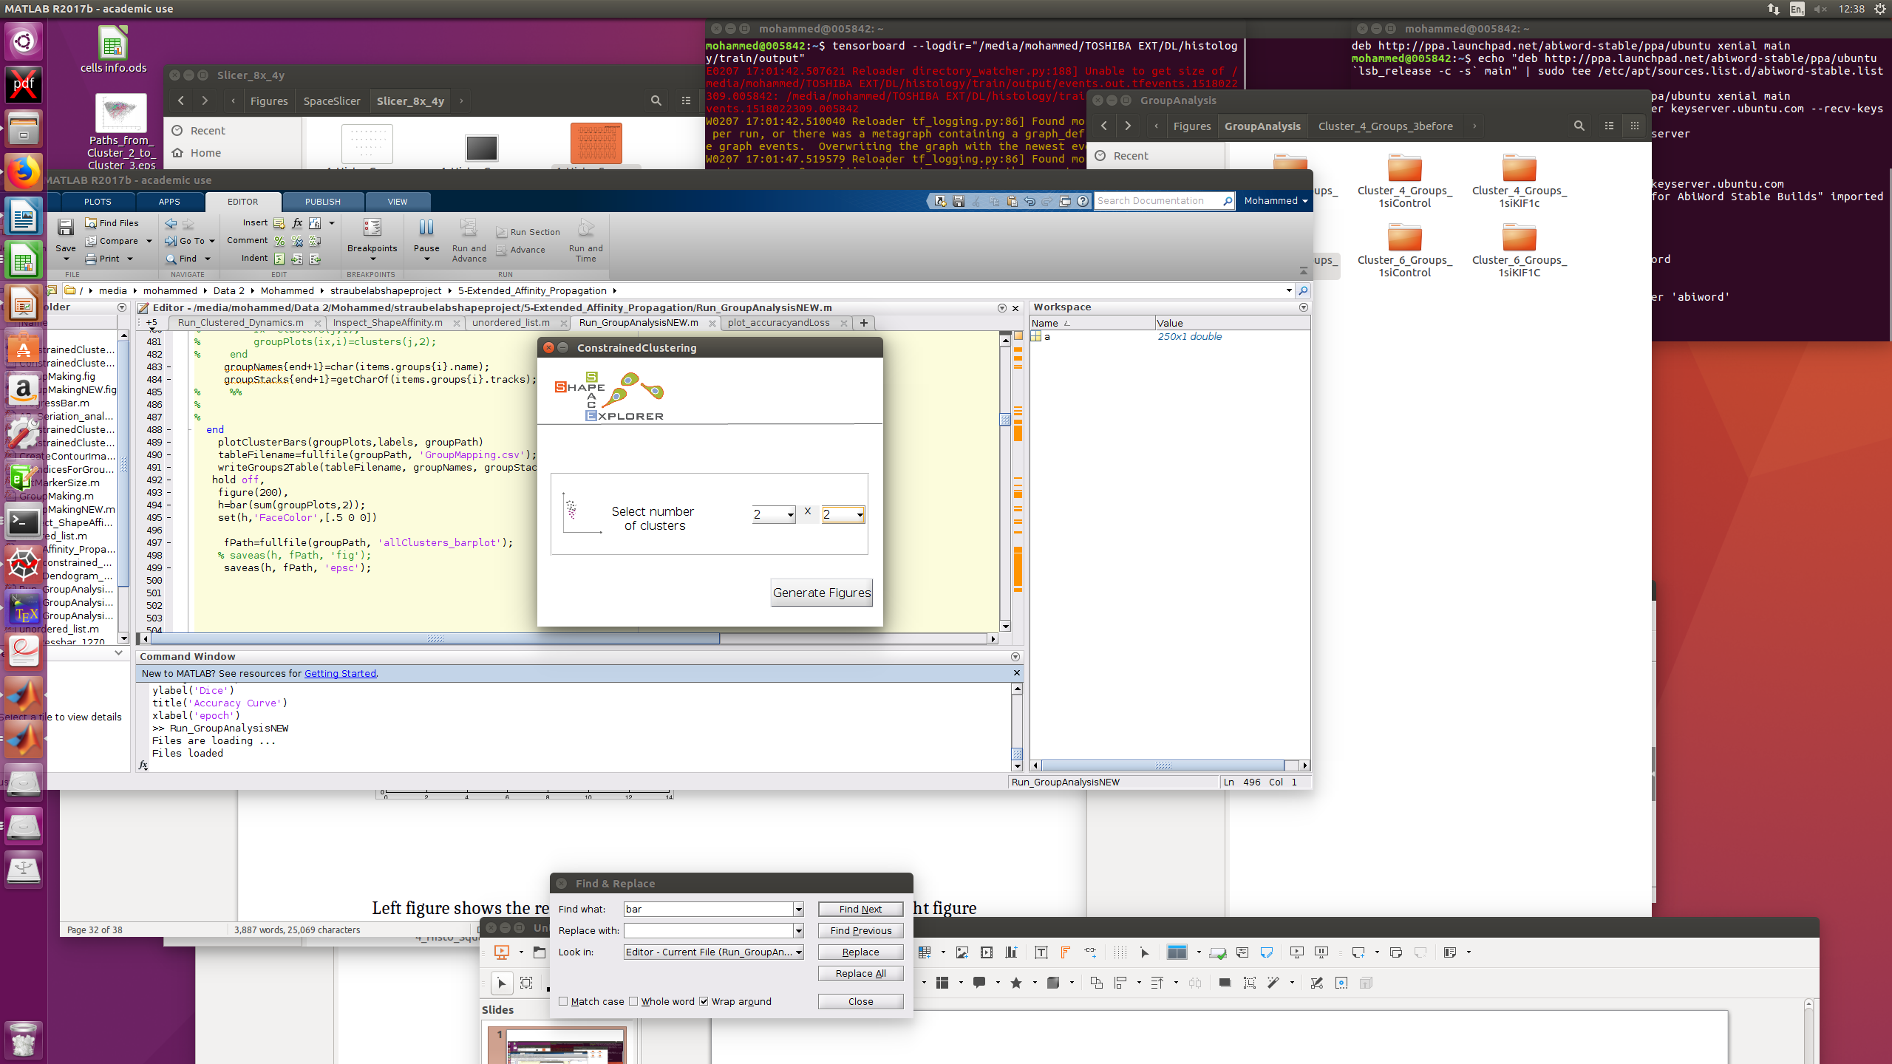

Once ‘Generate figures’ buttom is pressed, a GUI for Self Organizing Maps Neural Network for shape feature space clustering will be shown (see below)

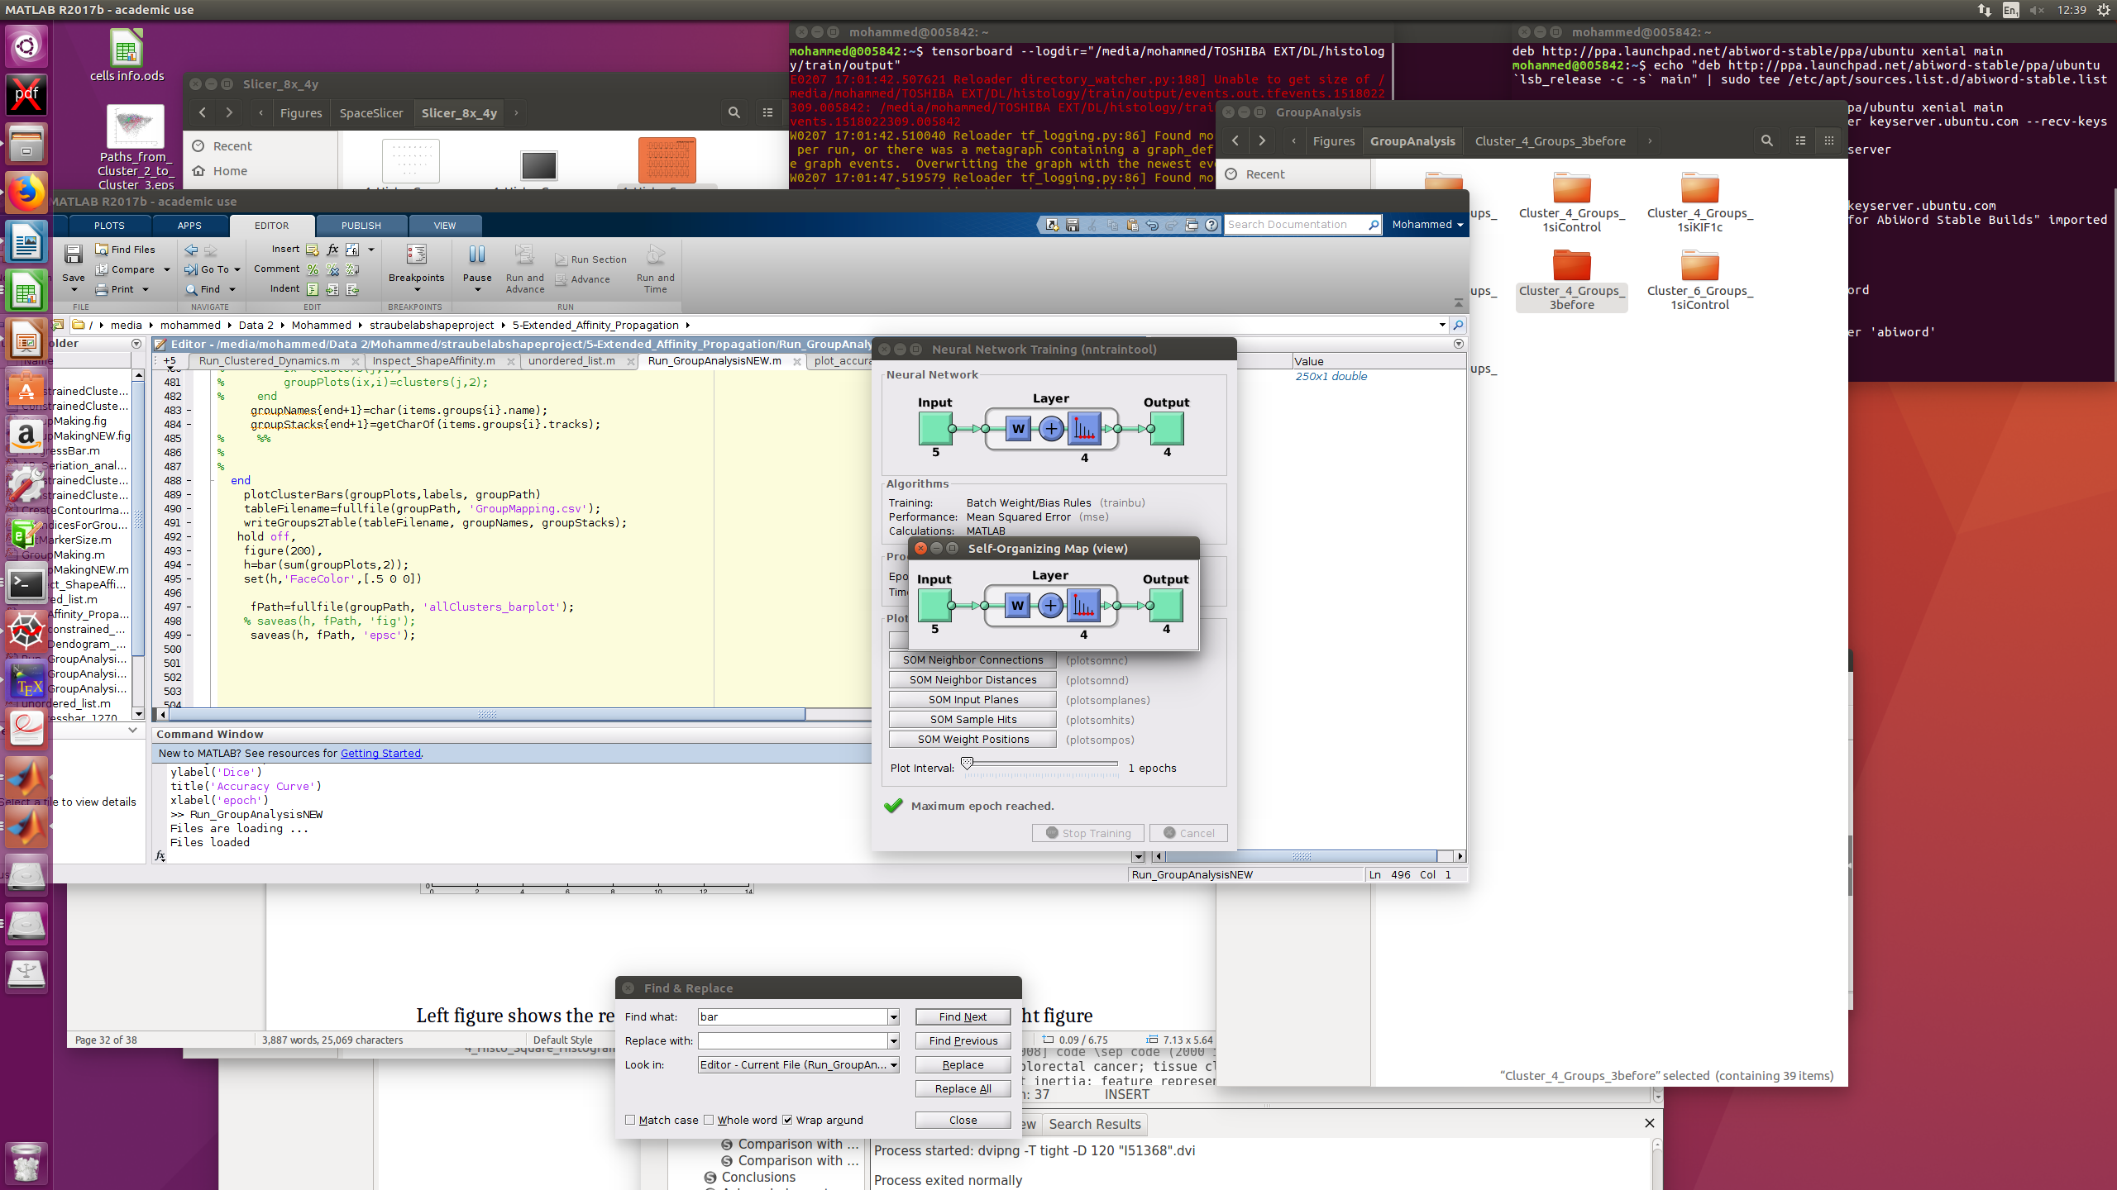

For each group analysis, the program creates a new folder with time stamp, for example “GroupAnalysis_2015-04-15_095836”. The folder contains the following figures for each group:





Top left images shows shape space in gray with all shapes from all groups. The Top right image shows all shapes in region colour. Second row (from left to right) show group elements in cluster colour and non-group elements in grey for three different groups: untreated, siControl, siKIF1C, receptively. There is also a number of figures that are generated for each group (see below).

Left figure shows the relative amount of shapes in the clusters, while right figure shows directionality as ratio of Euclidean distance over accumulated distance over different time lags for each group.

Left figure shows relative count of all groups with respect to region 1 (red), while right figure shows bar plots with absolute counts. For all bar plots, the numbers are written in text format in the Group Analysis folder.

Also, the averages speed in shape space is written in “AvgSpeedPerGroup.csv”. The unit of the speed is [unit in shape space/ time point difference]. If your movies took a frame every 5 minutes, than the respective unit would be

[1 unit in shape space/ 5 minutes].



Finally, you can select two regions (regionX and regionY) to calculate the speed of cells from regionX to regionY and vice versa, this by left-click anywhere at the target regions and once the regions have been selected, click-right anywhere in the figure to start the analysis.

Once done, the figure will be updated to show the number of regions that have been just selected.

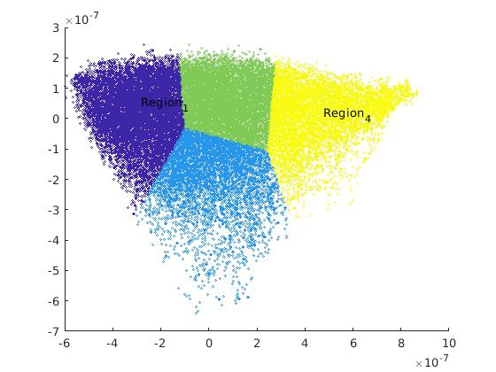

Note that the cluster numbers will be shown on the clustered shape space once you do click-right.

Also, the system will produce four figures as demonstrated below





First row (from left to right) shows paths of cells form regionX (e.g., the first selected region) to regionY and from regionY to regionX, respectively. Second row (from left to right) shows the speed of cells from regionX to regionY and vise versa, respectively.

## Step 7.2: Sliced shape dynamics

For dynamic data, start with pre-processing and run 7-ShapeSpaceDynamics→ Run_DynamicData_Generation.m and select the Analysis folder.

After successful completion, the program should have generated the file:

* DynamicData.mat

The inside of the DynamicData.mat consists of the following variables:

* struc.track: contains the x,y coordinates for a cell id in shape space, for each frame.
* struc.track: contains the speed for a cell id, for each frame.
* struc.average_speed: a single number, containing the average speed for a cell id.
* Struc.angles: contains the angle of a cell id for each frame.
* Struc.av_displacement_direction: a single number showing the average displacement direction.

Note: InspectData from 1st step, permits only cells with continuous detection to have the same id. Hence, per definition each cell id has equally distant time points, or in other word, no gaps in time points.

### Step 7.3: Sliced Shape Space Average Dynamics

This program permits to see the average behaviour of slices in shape space.

Run 7-ShapeSpaceDynamics→ Run_Sliced_Dynamics.m

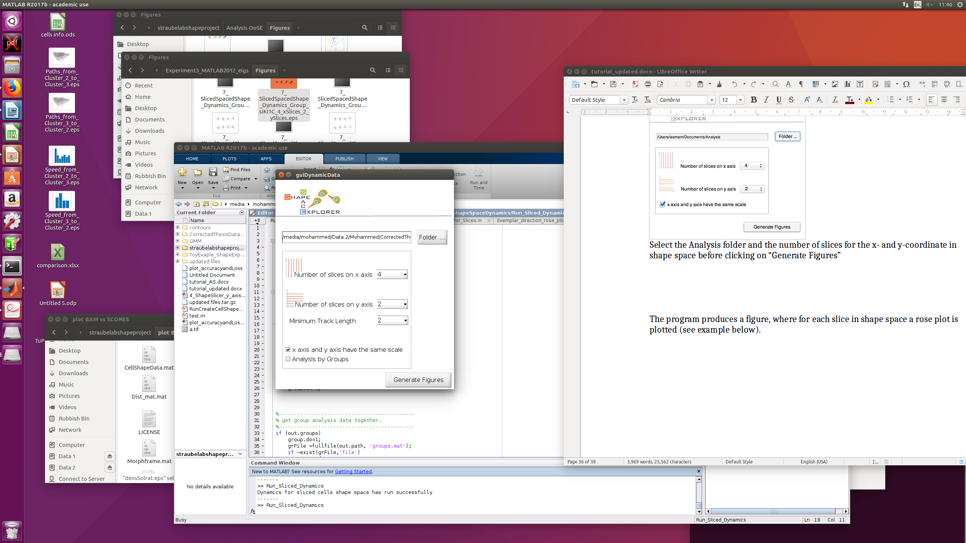

Select the Analysis folder and the number of slices for the x- and y-coordinate in shape space before clicking on “Generate Figures”

The program produces a figure, where for each slice in shape space a rose plot is plotted (see example below).



To see the rose plots per group, tick the last choice box (Analysis by Groups). Then, generate Figures

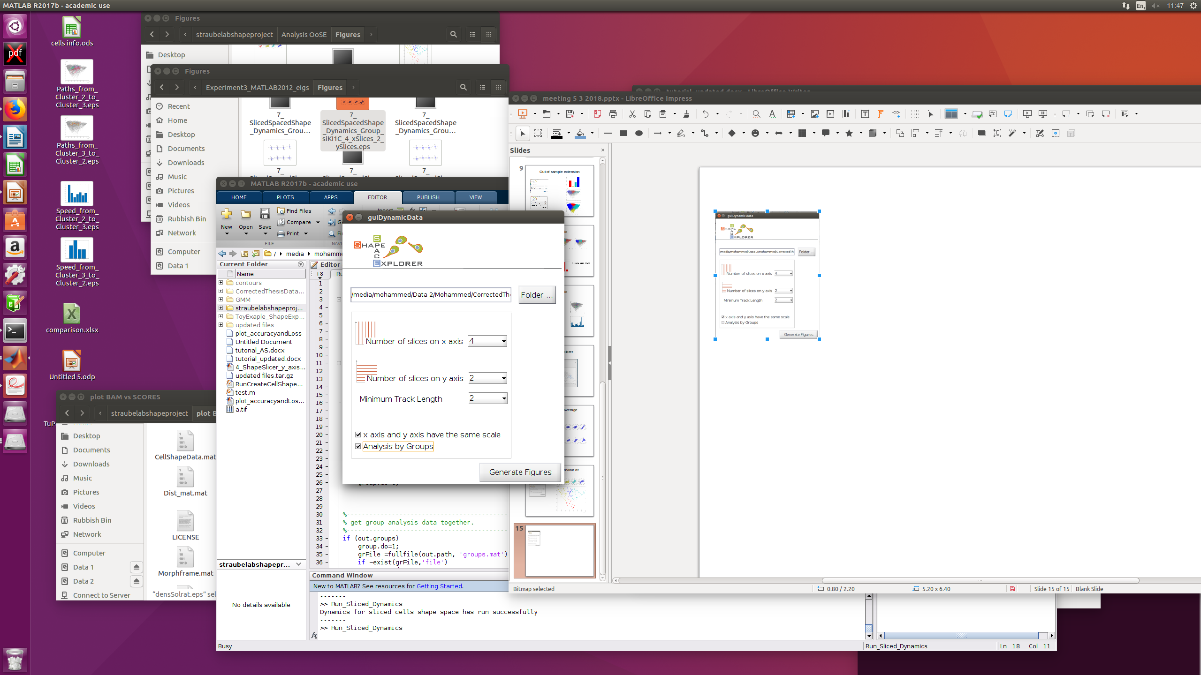

### The left figure shows the shape dynamics for the first group (siControl) while the right figure is for the second group (siKIF1C), where for each slice in shape space a rose plot is plotted.

### Step 7.4: Explore Average Behaviour of Clusters

Run 7-ShapeSpaceDynamics→ Run_Clustered_Dynamics.m,

Select Analysis folder, and number of optimal clusters (as determined in step 3 via the dendrogram).

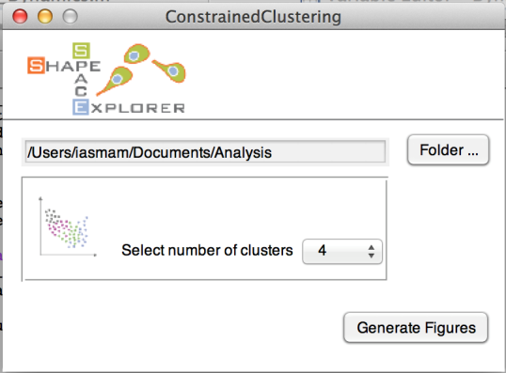

An example graph could look similar to the image below:

